TASK 10 – Packages and Encapsulation
Student Name: B. Muni Chandini
Register Number: 192524283

1. Package Structure (Recommended)
text
parking
├── model ← Vehicle, TwoWheeler, Car, ElectricCar, ParkingTicket
├── service ← ParkingFacility (business logic)
└── app ← Main / Demo classes
2. Access Modifiers Used
Member | Access Modifier | Reason
regNo | private | Cannot be changed or accessed directly from outside
ticketNo, floor, slot | private | Data hiding
Getters (getRegNo() etc.) | public | Controlled read-only access
ratePerHour() | protected | Only subclasses should implement it
Constructors | public / protected | Allow object creation
3. How Getters and Setters Validate Data
- No setters are provided for important fields (regNo, ticketNo, etc.) → immutable objects.
- Constructors perform validation:
  - Registration number cannot be null or empty
  - Floor and slot cannot be negative
  - Minutes cannot be negative
This protects the object from entering an invalid state.
4. Wrapper Classes & Autoboxing
- We used primitive int and double for simplicity.
- If we used Integer or Double, we must be careful with == (compares references) vs .equals().

5. Alternative Concept and Complexity Analysis
Current Design: Fields are private + validation in constructors/getters.
Alternative: Make fields public and let the calling code validate.
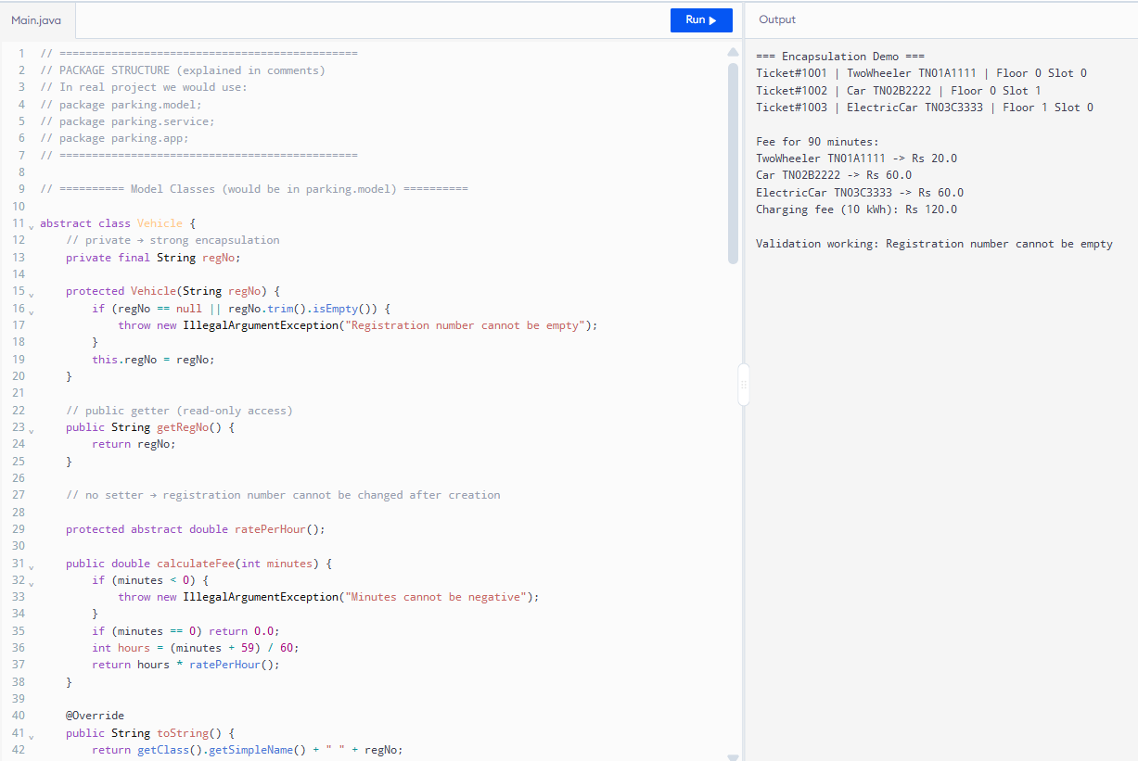
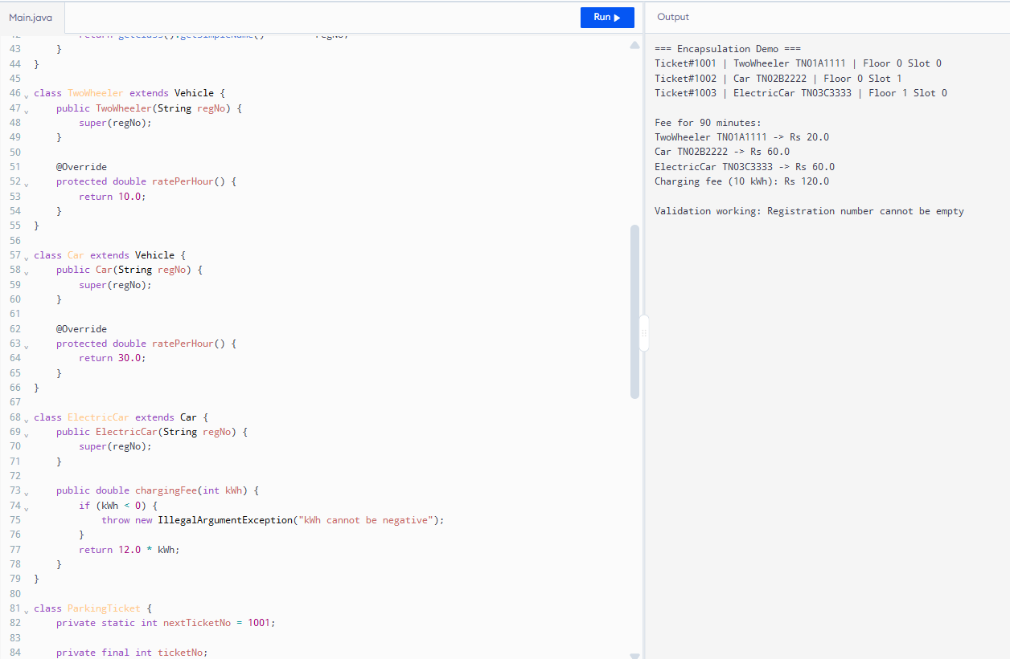
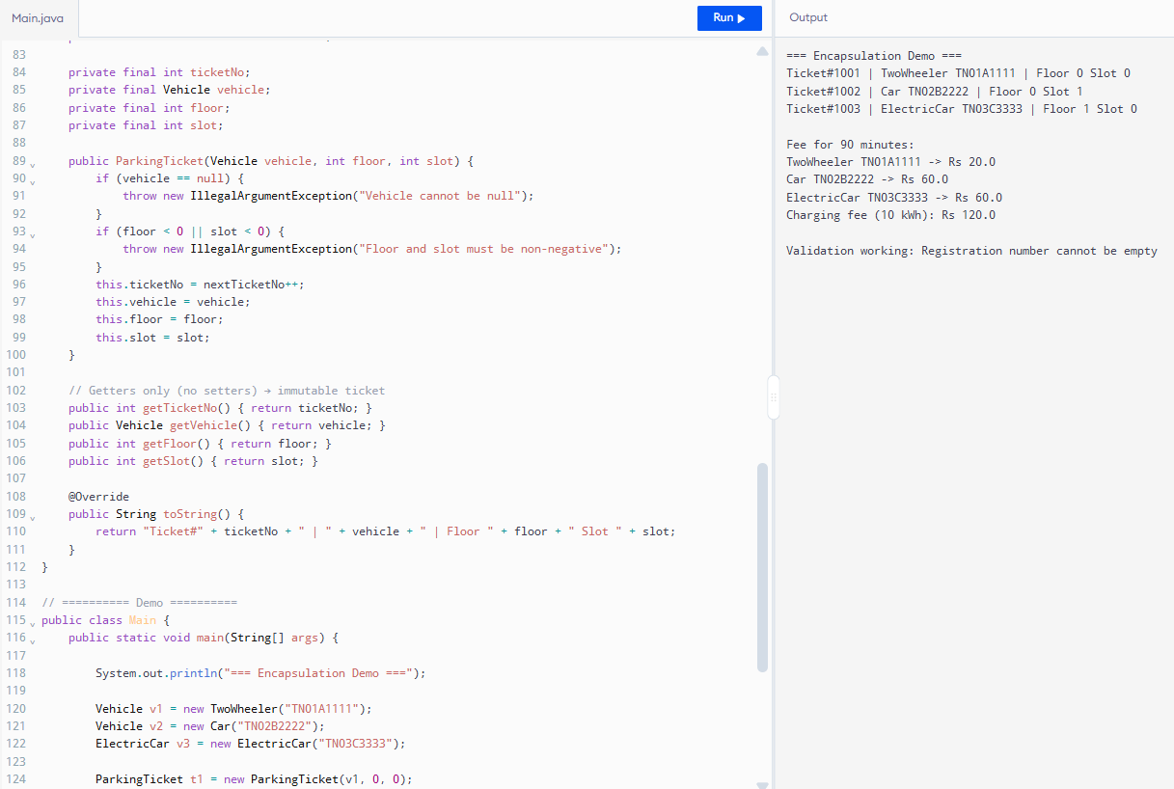
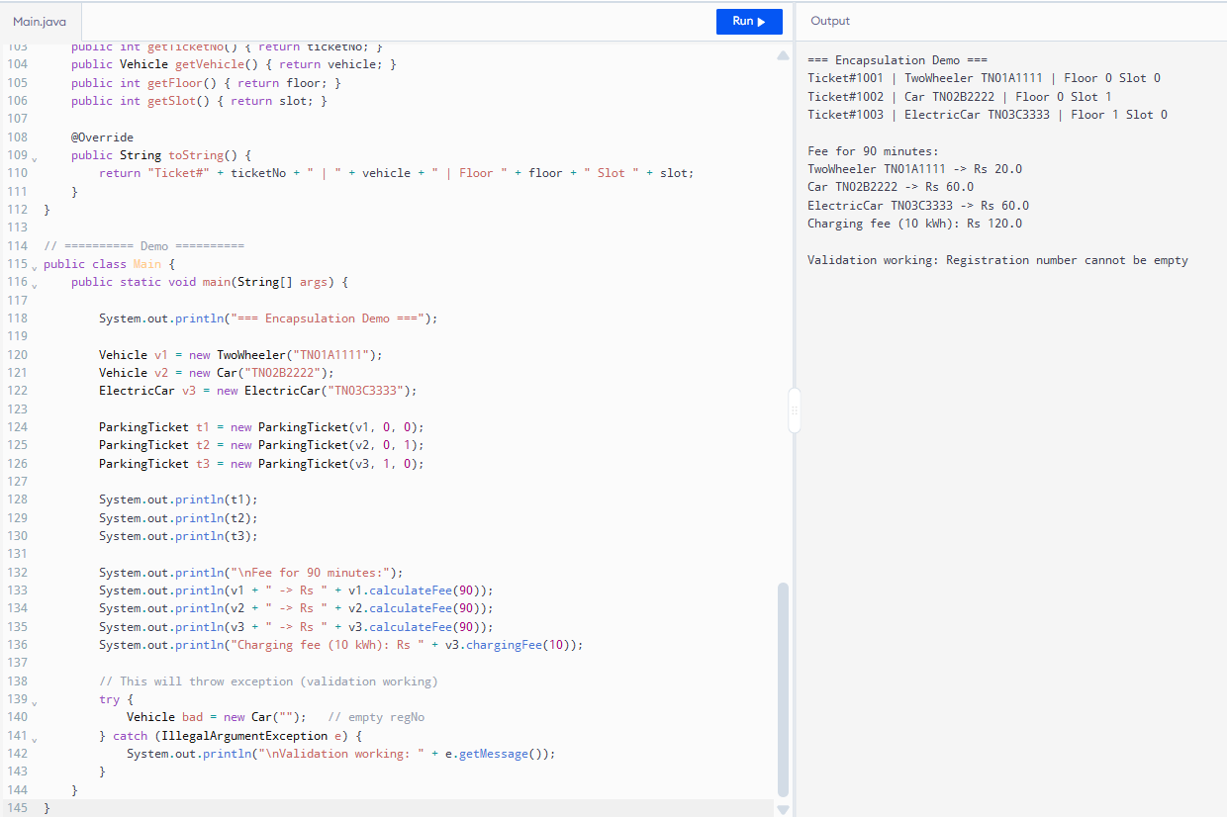
Aspect | Private + Validation (my design) | Public fields
Data protection | Strong | Weak
Number of places validation is needed | Only inside the class | Every place that uses the object
Risk of invalid objects | Very low | High
Time cost of validation | Paid once at creation | Paid every time (or forgotten)
Conclusion:
Encapsulation with private fields and validation is much safer and reduces bugs.

